The UAE Accountability Authority (UAEAA)

The UAE Accountability Authority (UAEAA) is the supreme institution for financial audit and accounting in the UAE, operating directly to the President of the UAE. Its primary objective is to foster integrity, transparency, and accountability within the United Arab Emirates. To this end, the UAEAA holds a critical role in safeguarding public funds by diligently monitoring the financial and operational activities of the federal entities across the UAE.
Moreover, the UAEAA, employs measures and strategies to ensure the highest standards of ethical conduct and effective governance.

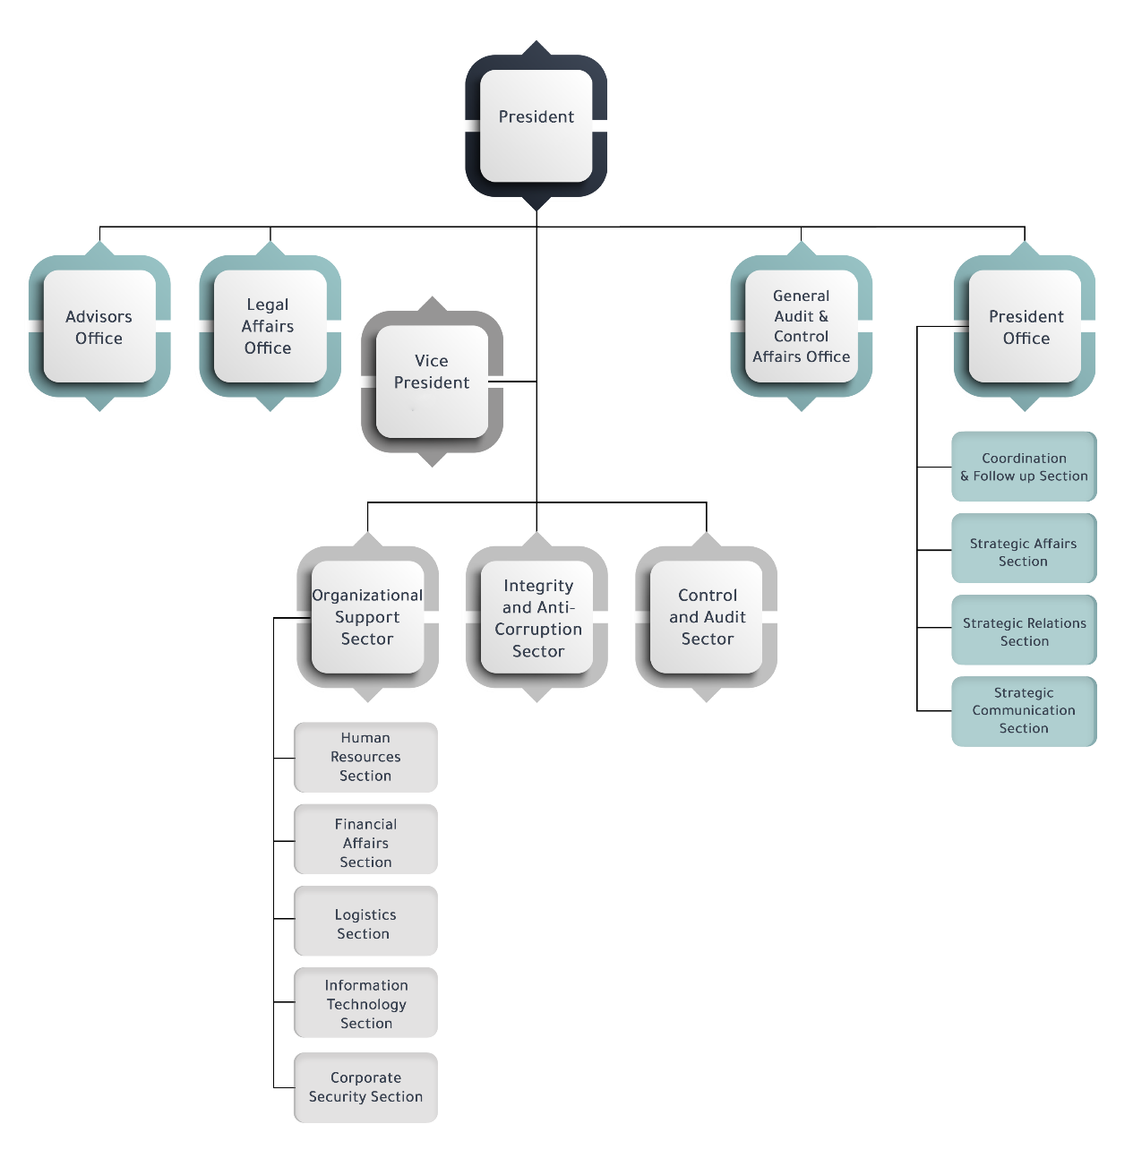
Organization Chart

The UAEAA is headed by a president, who is the Auditor General in accordance with the Constitution, where UAEAA enjoys the constitutional and legislative guarantees to maintain its independence and carry out its tasks without any influence.
In addition to the mandate of audit competencies, which are financial and compliance audit, performance audit and IT audit, it is also mandated to prevent, detect and combat corruption through law enforcement. In such cases, the UAEAA conducts investigations on instances of corruption and financial violations, whether these have been detected by the UAEAA or received through the various reporting channels.
UAEAA takes precautionary measures to preserve public funds such as reservation of funds, travel bans and suspension of work in coordination with the competent authorities. Criminal offenses identified are referred to the Federal Public Prosecution for further investigation and action.
UAEAA submits its annual general report to the President of the State and inform the Cabinet and the Federal National Council. UAEAA reports on audit results are binding, and the entities must fulfill the request of t UAEAA o meet its requirements and adopt the procedures required to avoid defects, rectify mistakes and collect the amounts wasted, illegally disbursed, due amounts or those where the collection was neglected within a month from notification date. Noncompliance with the recommendations of audit reports is considered a financial violation resulting in investigation and the taking of necessary measures in this regard.
The Supreme Audit Institution of the United Arab Emirates acts as the central point for cooperation between the Public Prosecution, the Ministry of Interior, the Central Bank and the Ministry of Finance in matters of anti-corruption strategies and cases relating to suspected corruption offences. In addition, is responsible for coordinating all international cooperation related to anti-corruption strategies, cases and the safeguarding of public funds in this regard, including with the entities noted above.
The UAEAA contributes to the national anti-corruption strategy through the exercise of its audit competencies and by examining the various financial and accounting laws, rules and regulations and the progress of the financial operations of the auditees in order to ensure their soundness, determine areas of improvement and propose the means it deems necessary to achieve such improvements. This includes the development of accounting standards and best practices as well as the conduct of studies and research and to propose establishing or amending systems and policies in order to increase the levels and capacities of preventing and combating
corruption. Further, the UAEAA issued a guide to best practices in combating corruption, with the aim of providing public sector institutions and entities with the necessary tools to improve the use of public funds.
In the UAE, all procurement procedures across all stages are outlined in the procurement law. The law regarding the control of these systems is under the control of the Ministry of Finance, with the UAEAA required by law to audit those government entities.
UAEAA as an external auditor is required to prepare an audit plan annually, based on a risk assessment and by understanding each public institution and its control environment, evaluation and implementation of internal controls, preliminary analytical procedures, and the matters arising from audit team meeting proceedings the work of internal auditors. This information helps to identify risk, determine the audit objectives and the audit work to be performed.

UAEAA has powers:

- To review and examine any documents and records whether hardcopy or electronic, and may pursue any person or asset with a Federal Government Ministry of organization.
- To compel submission of documents and records whether hardcopy or electronic, or summon persons so he can perform his functions and duties.
- Of right of access to information whether hardcopy or electronic pertaining to outsourced or contracted out services and functions of Federal Government Ministries and organizations.
- Of right of access to information whether hardcopy or electronic even if it is deemed commercial–in–confidence by a Federal Government Ministry of organization.
- Of right of access to interview people for the performance of its functions and duties, whether they be Ministers, Under Secretaries, chief executive officers, employees, contractors, consultants, suppliers, or any other person. A person interviewed by UAEAA is compelled to answer and to answer truthfully.
- To review and examine any internal audit documents and records whether hardcopy or electronic of a Federal Government Ministry of organization.
- To enter the premises of a Federal Government Ministry of​ organization, or any other entity to perform his functions and duties without notice and without need of any authorization except for proper identification issued by UAEAA.
- To appoint contract auditors and other relevant external expertise to supplement UAE resources.
- To order the presence of UAE to any meetings of a Federal Government Ministry of organization to perform its functions and duties
- to attend audit committee meetings of a Federal Government Ministry of organization in observer capacity.

